Note: This document is “view only”. Please create a copy of this document and save it to your drive.

**SOP- Reassigning Tasks for Leave- Systems Vault**

**PREREQUISITES**

[Master: SOP- Staff Leave- Systems Vault](https://docs.google.com/document/d/1YPqCJZGbZCYOSZIuZasErqMDSNA0Z3S2gq1Iib8w-20/edit?usp=sharing)

[Teamwork PM](http://sarahnoked.com/teamwork)

**PURPOSE**When taking a leave of absence it is important that all tasks assigned during the leave time are reassigned accordingly so that no tasks fall between the cracks.

**POLICY**

The team member who is taking leave is responsible for ensuring that all their tasks are taken care of in their absence.

**PARTY**

All Team Members

**PROPERTY**

Online Business Manager

**PROCESS**

Part 1: Review tasks, update due dates or reassign

Part 2: Putting reassigned tasks back in place

**PROCEDURE**

**Part 1: Review tasks, update due dates or reassign**

1. Filter your tasks for the time you will be away
   1. If the task can be pushed, discuss with the Online Business Managerand update the task to when you will return.
   2. If the task needs to be reassigned, add an additional person to the task (while still keeping yourself of the task)
      1. Select the “Who Should Do this Field” and the click on “Choose More”

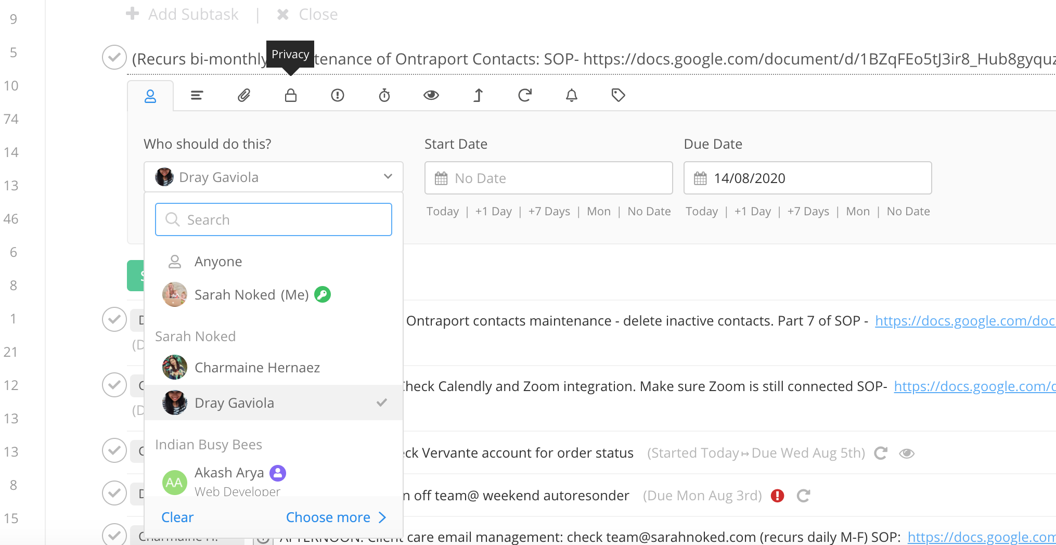

* + 1. Add the team member who will be responsible for manning the task while you’re gone (while still keeping yourself on the task for easy switching when you get back)

**Part 2: Putting reassigned tasks back in place**

1. Upon your return filter your tasks and remove the person who was added in your absence.
2. Follow up accordingly and check in with the team members to ensure the work was completed properly.

**Created by:**

**Department:** Operations & Support

**Date:**

**Revised:**

**Revised by:**